SAME ROW BUTTONS

SAME ROW BUTTONS
- In order to put buttons on the same row, we need to implement a frame widget
- We will then put our buttons inside this frame widget
- Then, when we create our buttons, we will specify the parent window parameter with the object variable that holds our frame, instead of our root-window

FRAME
- Because we want our buttons right under our entry widget, we'll initialize our frame right after the listbox and give it the same vertical padding as the Add Task button had
- NOTE that we are not filling or expanding our frame when we use .pack( )
  - .pack( ) automatically places widgets in the top-center of available space

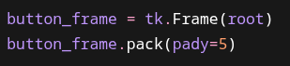

BUTTONS
- Now when we create our buttons, we specify the parent window parameter as our frame widget
- To place them side-by-side, we specify side=left in .pack( )
- Because we want the delete_task button to be first, we will pack this widget before our add_task button
- We'll add a little bit of horizontal padding to add some space between the two buttons

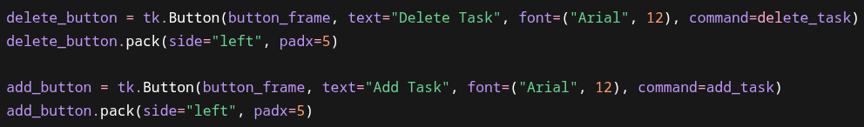

FULL CODE

import tkinter as tk
import json
root = tk.Tk()
root.title("Task List")
root.geometry("500x450")
tasks = []
def add_task(event=None):
description = task_entry.get()
if description == "":
return
task = {
"description": description,
"completed": False
}
tasks.append(task)
task_listbox.insert(tk.END, description)
save_tasks()
task_entry.delete(0, tk.END)
def delete_task():
selected = task_listbox.curselection()
if selected == ():
return
index = selected[0]
task_listbox.delete(index)
tasks.pop(index)
save_tasks()
def load_tasks():
global tasks
try:
with open("tasks.json", "r") as file:
tasks = json.load(file)
for task in tasks:
task_listbox.insert(tk.END, task["description"])
except FileNotFoundError:
tasks = []
def save_tasks():
with open("tasks.json", "w") as file:
json.dump(tasks, file)
task_listbox = tk.Listbox(root, font=("Arial", 14), width=40, height=10)
task_listbox.pack(pady=10)
load_tasks()
task_entry = tk.Entry(root, font=("Arial", 14))
task_entry.bind("<Return>", add_task)
task_entry.pack(pady=10)
button_frame = tk.Frame()
button_frame.pack(pady=5)
delete_button = tk.Button(button_frame, text="Delete Task", font=("Arial", 12), command=delete_task)
delete_button.pack(side='left', padx=5)
add_button = tk.Button(button_frame, text="Add Task", font=("Arial", 12), command=add_task)
add_button.pack(side='left', padx=5)
root.mainloop()

